

**Assignment - 1**

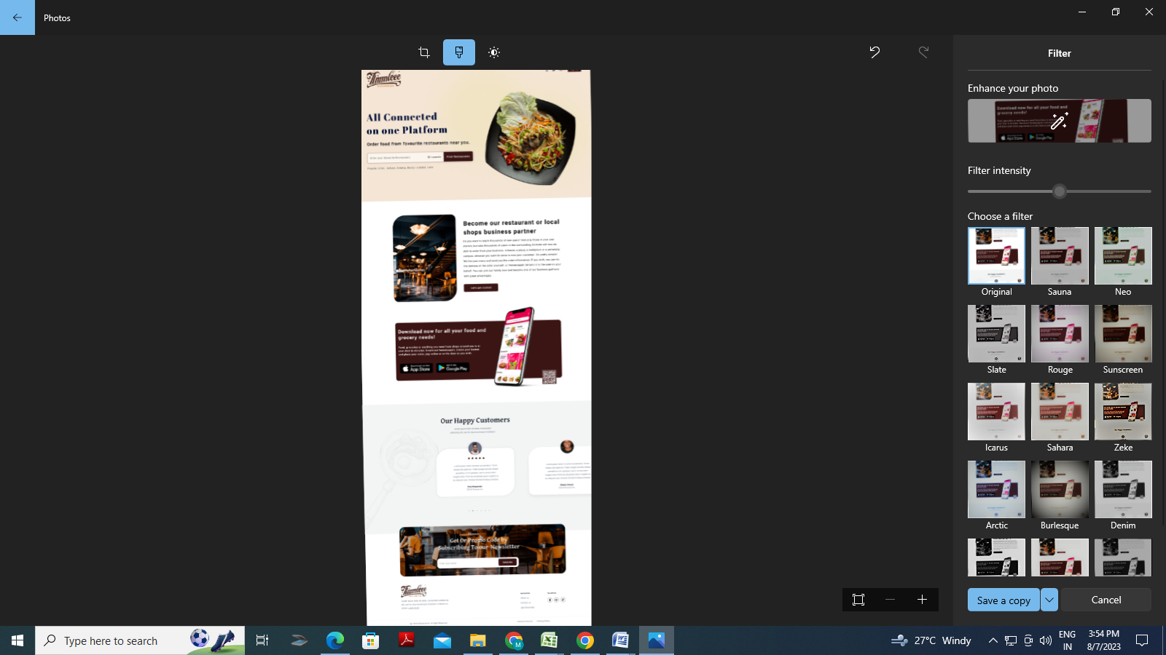**Trainer Name - Date:  
HTML-CSS**1. Convert this Mock-up from HTML to CSS.

**JAVASCRIPT**  
2. Write a program to calculate multiplication and division of two numbers.  
3. Write a program to convert temperatures to and from Celsius, Fahrenheit.  
4. Write a function that checks whether a passed string is palindrome or not.  
5. Write a function that returns a passed string with letters in alphabetical order.  
6. Write a function takes an argument and returns the type.  
7. Write a function to calculate the value of mn where n is the exponent and m is the base. take both values from user and show result.  
8. Write a function to extract unique characters from a string.  
9. Write a function to get difference between two dates in days.  
10. Write a function to convert a string into camel case  
11. Function to find a word within a string.  
12. Create a form with all type of fields and add value in this. After submit form all values should be visible in a div with all proper label and its value with good design.

13**.** Create a form with following fields:  
 Name, email, state, and city, save button.   
14. When state will change, city field options will be updated accordingly.   
15. Develop this example with multidimensional array.  
16. After adding values in all fields and hit on save button store values in an array. show result in table format below the form.  
17. Use mouse hover and mouse out event to update design of save button.18**.** JavaScript program to test the first character of a string is uppercase or not  
19. Pattern that matches e-mail addresses  
20. Function to check whether a given value is an valid url or not  
21. All fields are required.  
22. Both passwords should be same.  
23. Password must contain at least one cap letter, one number and one special character.  
24. Only alpha characters should be allowed in name field.  
25. Username should contain only alphanumeric and underscore.26**.** Practice all examples given in slide.  
  
**J-Query**  
27. Create above task assignments using jquery.  
28. Create slide-show with button and mouse hover event with static images path in an array.  
29. Take the css style in textboxes and apply on a div.  
30. Implement above task assignments with jQuery form validation plugin.  
31. Create a grid and make that inline editable.  
32. Install and use owl carousel plugin.  
33. Use jquery image zoom plugin.  
34. Use fancybox plugin.  
**DATABASE**35**.** Learn about DBMS Architecture  
36. Find difference between file server and database server  
37.Create database and table for learning management system   
 Table Name: - User, Course , modules, and class  
38. Create a ER diagram for the same database  
39. Create Customers and orders table in your database name dbclass2  
40. Insert some dummy data in the table  
41. Get OrderID CustomerName form Orders table using INNER JOin  
42. Get CustomerName and OrderID from Customers table using left join  
43. Get OrderID, CustomerName form order using right join  
44. Get CustomerName, OrderID from Customers using full order join  
45. Apply GROUP BY on user id in the order table  
46. Apply GROUP BY on user id in the order table  
47. Apply all aggregate function on order total.